☑ 1. Skull stripping
Visualization of Surface Extraction and Surface Volume Registration Outcomes
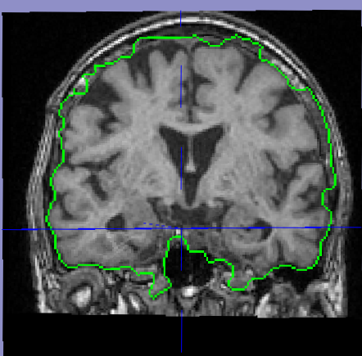
☑ 2. Skull and scalp
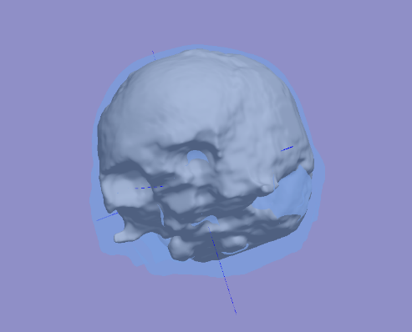
☑ 3. Nonuniformity correction
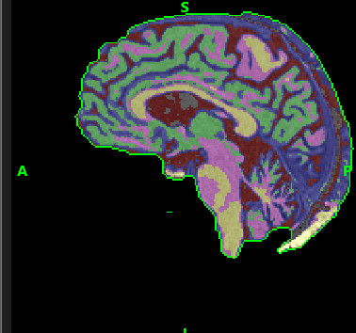

☑ 4. Tissue classification
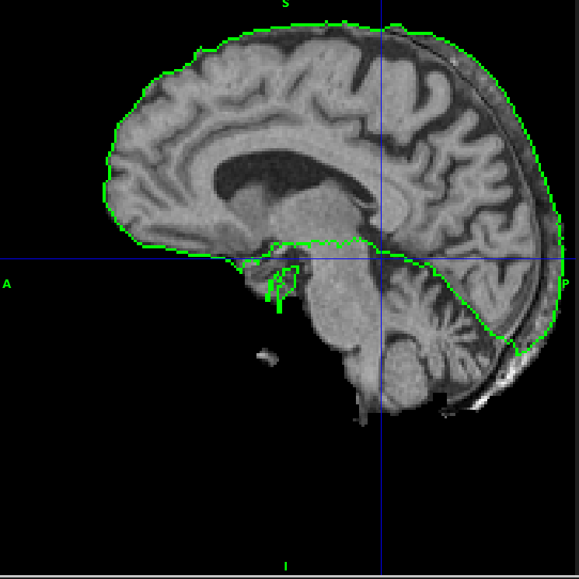
☑ 5. Cerebrum labeling
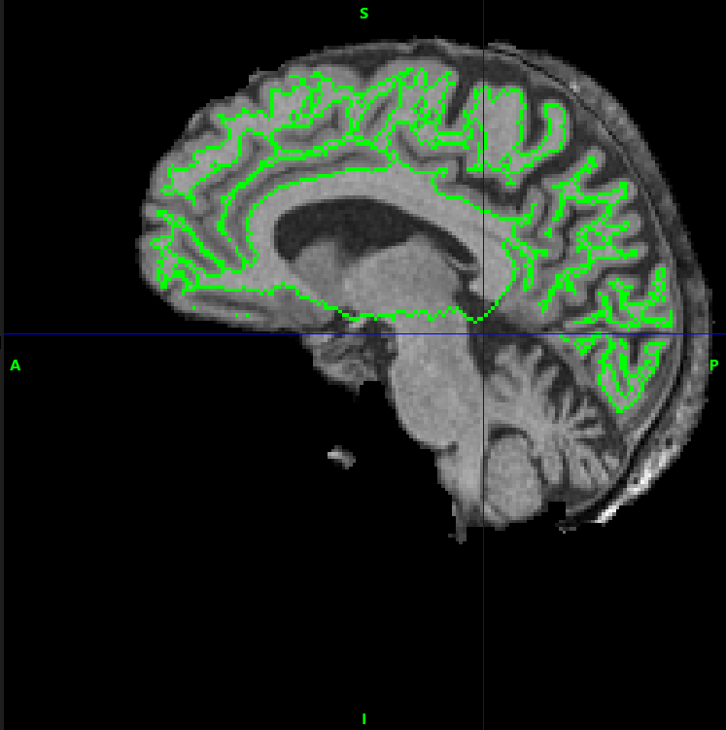
☑ 6. Inner cortical mask
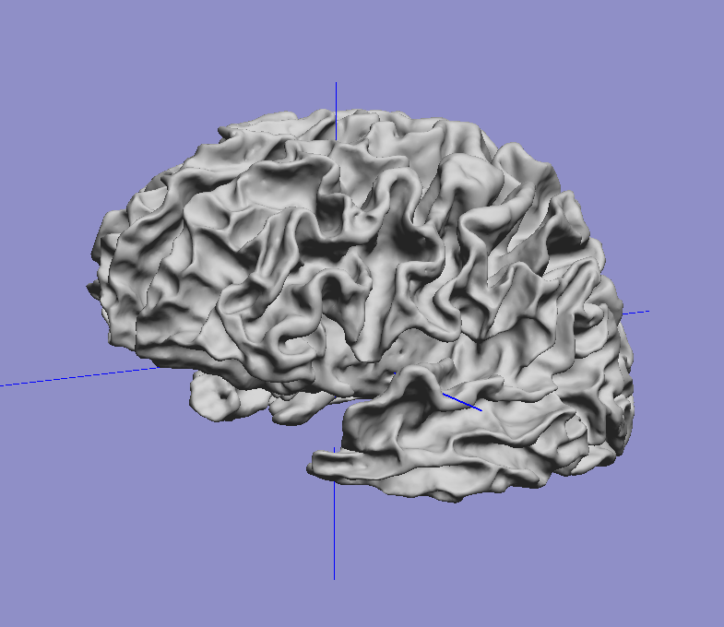

☑ 7. Wisp removal
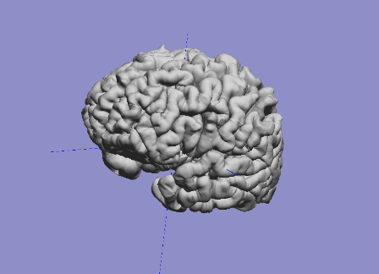
☑ 8. Split hemispheres
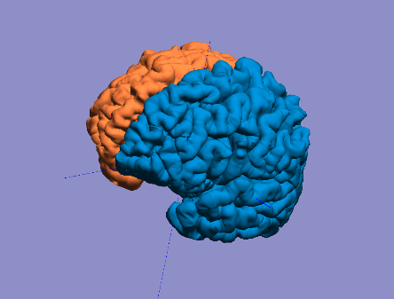
☑ 9. Register and label brain
